Year 4 Home Learning: Summer 2 – Week 3
Working together to achieve success’

Hello Year 4. Here is the timetable this week to support learning at home which combines online learning platforms with paper based activities you can view on screen and complete in your exercise book from school. We do not expect families to print resources off! I also want to know what you have been busy doing, so
Please, please email me at year-4@mossgate.lancs.sch.uk and I will share these on our school’s Facebook page. The e-mails are regularly picked up so please use the email address if you have any questions about the learning as well.
Take care and keep safe.
Mrs Elwers

Daily PE:
Start the day with 20-30 minutes of physical activity. Suggestions include: Joe Wicks Daily PE
lesson Natasha Butler Daily Workout / Just Dance videos in YouTube. Additional physical activity are
uploaded weekly onto our school website at:
https://lancashireschoolgames.co.uk/year-3-6-spar-lancashire-school-games-activity-timetable/

Daily Newsround:
Watch the 5 minute news summary daily at 12:15pm by going to https://www.bbc.co.uk/newsround and click
‘Watch Newsround’ in the top right hand corner. Discuss topical items in the news and research any aspects
which interest – this could be a topic, country or person. Newsround is updated daily. You could even produce
your own news report on one of the topics and share it with us!

Maths:
Go to https://whiterosemaths.com/homelearning/year-4/ to access the video resources. Use the video to help explain the concept and then complete the activity (in your exercise book) which you can access by accessing the school website and following this path: ‘Summer 2 Home Learning – Week 3 – Year 4’.
 | Monday | Tuesday | Wednesday | Thursday | Friday
Mental Maths | Complete 15 minutes of IDL Numeracy (https://idlsgroup.com/) and/or Times Tables Rocks Stars (https://play.ttrockstars.com/auth/school).
 | You will find the videos and PowerPoint presentations by following the White Rose Maths link and clicking on Week 7 (w/c 8st June). The sheets required for each day have been downloaded and are accessible by following: ‘Summer 2 Home Learning – Week 3 – Year 4’.
White Rose Maths | Lesson 1 –  Tenths as decimals | Lesson 2 –  Divide 2 digit by 10 | Lesson 3 –  Hundreds as decimals | Lesson 4 –  Divide 1 or 2 digits by 100 | Lesson 5 –  Friday challenge

English: Focus theme- The secret Lake
Focus text: The Secret Lake by Karen Inglis Embark on an adventure with The Secret Lake by Karen Inglis. Two siblings, Tom and Stella, who have recently moved to London from Hong Kong, try to solve the case of a disappearing dog!
When following links, parents should monitor that children are remaining on that page only and are keeping safe online.
.
Also: Complete 15 minutes of IDL Literacy (https://idlsgroup.com/) daily which develops spelling, comprehension and keyboard skills.
Mon | Before you begin to read the extract, have a look at the picture of the book.  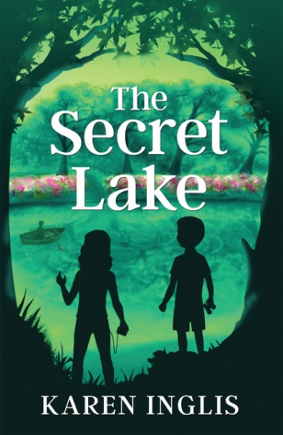  What can you see? Who do you think the characters are? What is in their hands? What are they doing?  Write down your answers to these questions in your book.  Download the pdf The secret lake  Home learning – Summer 2- Week 3 – Year 5  The title is The Secret Lake. Can you make any connections with the book? Have you read any books before that have taken the characters to a secret place? Can you think of any films/TV shows that take you to a secret place? Have you ever been to a secret place?  Write a short paragraph about any connections that you make,  e.g. This book reminds me of … because …  Now have a look at the words below; do you know what they mean?  mercilessly, tuft, squinting, loomed, array, communal, vast  Complete a chart like the one underneath this table including definitions (what the word means) and synonyms (words that mean the same).  Use a dictionary to find definitions and synonyms
Tues | Read Chapter 1 of the extract.  Home learning – Summer 2- Week 3 – Year 5  Spot the vocabulary that you explored yesterday. If you have printed the extract out, then you can highlight the words when you spot them. Think about their meaning in the sentences in which they appear. Think about the characters of Tom and Stella. What are your first impressions of them? How are they similar to each other? How are they different?  Compare the characters using a Venn diagram.  Explain your Venn diagram to someone in your household. Try to support points you have made with evidence from the text. E.g. I can say that Tom is …. I know this because in the text it says ….
Wed | Read Chapter 2 of the extract  Note down any unfamiliar vocabulary and find out the definitions.  https://www.wordhippo.com/  Imagine that you are Stella or Tom. You are going to write a diary entry for one of them. Think about what has happened that day and how you are feeling as either Stella or Tom.  Steps to success  - Write in first person (you are Stella or Tom)  - Write events that have happened that day in chronological (time) order  - Include how you (Stella or Tom) are feeling about the things that have happened.  - Try to include some of the new words that you have explored this week.  Think about also including some of our Year 4 grammar/ sentence types we have looked at:  - Fronted adverbials  - Complex sentences  - Paragraphs  Read your work through and check for spelling and punctuation. Could you improve your writing in any way?
Thurs | Have a look at the words below; do you know what they mean?  scout, hollow, trotting, loomed, soundly, jaunt  Complete a chart like this one. Use a dictionary to find the definitions.  Now read Chapter 3 of the extract  Home learning – Summer 2- Week 3 – Year 5  Can you spot the vocabulary that you have been exploring? Think about their meaning in the sentences in which they appear.  What do you think is going to happen next?  Will Tom and Stella find Harry?  Where is the water coming from?  Will they have an adventure?  What will they find?  Will they tell anyone or keep it a secret?  Will the gardener catch them?  I’d like you to plan the next chapter of the story today before writing your chapter tomorrow.  Consider the questions above. Think about the title of the book. How does this tie in with the story? How can you make your story exciting? Plan your chapter using a story mountain
Fri | Today you are going to write the next part of the story from the plan that you created yesterday  When you are writing, think about the following:  -write in the past tense  -write in third person (Stella went … they found … etc.)  - Use paragraphs when you change scene or change time  - Use some of the words you have explored this week  - Include some Year 4 sentence types/ grammar skills that you have covered, e.g. fronted adverbials for where or when, or complex sentences with adverb starters (Carefully lowering himself down from the tree, Tom surveyed the uneven ground in front of him.)  - Include some dialogue between the characters. Make sure that you use inverted commas (“.”)  e.g. “I wonder where Harry goes every time,” Tom said with a frown as he picked at the mound of grass with his trowel.  Remember to keep reading through your work to check it makes sense and to check for spelling and punctuation.

Topic
Mon | Online Safety  Week 3  Alfie’s videos  Watch Episode 1: Block Him Right Good, Alfie again at  www.thinkuknow.co.uk/8_10/watch/  Look at Resource Sheet 1 found at the bottom of this page.  Alfie’s profile. Alfie has taken some important steps to make sure that he is safe when he is making videos and posting them online.  Write down four steps Alfie has taken in your exercise books.
Tues | 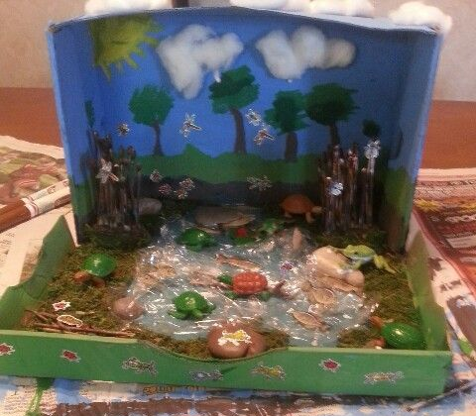  Think about the animals that can be found living in or around a lake. I’d like you to create a model habitat of a lake like that of the secret lake. Have a look at these examples…  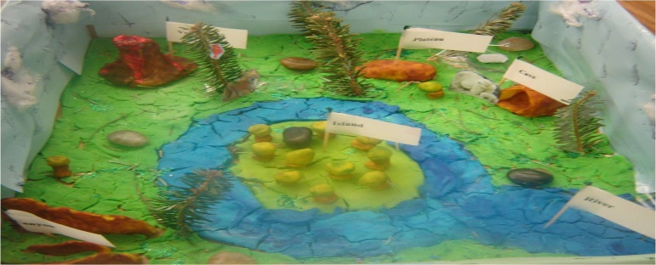
Wed | Science – Food chains  Have a look at this website https://www.bbc.co.uk/bitesize/topics/zbnnb9q/articles/zwbtxsg watch the video and read the information. Once you have done this have a go a re-ordering the food chain and doing the quiz. What score did you get?  Read the PDF ‘food chains’  Home learning – Summer 2- Week 3- Year 4- Food Chains  Using the food chain pictures can you use these pictures of animals to create food chains in your book?  - Created a food chain that has one carnivore and one herbivore  - Created a food chain one producer, primary consumer, secondary consumer  - Created a food chain where the last consumer is an omnivore  If you would like an extra challenge you can download the PDF ‘food chain challenge cards’ there are some more food chain challenges you can complete.  Home learning – Summer 2- Week 3- Year 4- ‘ Food Chain Challenge cards’  Or you could try to complete the food change pyramid which can be found.  Home learning – Summer 2- Week 3- Year 4- ‘ Food Pryamid
Thurs
Friday | Topic  Complete an activity from the topic learning grid that you have not yet completed.  Go to the school website: Home Learning - Summer 2 – Week 1 – Year 4 – Habitat Learning Grid. Don’t forget to share the tasks that you have been doing with me.

Did you get them all?
1. Profile picture is an avatar, not an actual photo
2. Username does not feature his name.
3. Privacy set to friends only.
4. Wears clothes that are not school uniform or private, like pyjamas.

